**Maybank LiveHelp User Guide**

By

API & Emerging Tech

Strategy & IT Architecture, MSS

Contents

1 Introduction 4

2 User Account 4

2.1 Create User 4

2.1.1 Go to Settings > Users 4

2.1.2 New User 5

2.1.3 Fill User Information 5

2.2 Assign Departments 6

2.2.1 All Department 6

2.2.2 By Individual Department 6

2.2.3 By Department Groups 7

2.3 Pending Chats 7

2.3.1 Automatic Accept Chat 7

2.3.2 Maximum Active Chats 8

2.3.3 See All Chats 8

2.4 Agent Account List 8

2.4.1 Search Agents 8

2.4.2 Delete Agents 9

2.4.3 Edit Agents 9

2.5 Agent Account 10

2.5.1 Edit Personal Information 10

3 Chat Configuration 11

3.1 Auto Responder 11

3.1.1 Welcome Message 11

3.1.2 Pending Chat Message 11

3.1.3 Agent Not Response Message 12

3.1.4 Hold Chat Message 12

3.2 File Attachment 13

3.2.1 Upload File 13

3.2.2 Attach File in Chat 13

3.3 Block User 14

3.3.1 By Country 14

3.3.2 By IP Address 14

3.4 Chat Assignment 15

3.4.1 Auto Assign Chat 15

3.4.2 Active Chat per User 15

3.4.3 Active Chat per Department 15

3.4.4 Auto Assign Chat to Other Operator 15

3.4.5 Delay between Chat Assignment 16

3.5 Message Character Limit 16

3.5.1 Maximum Message length in Character 16

3.6 Canned Message 16

3.6.1 Department 16

3.6.2 Personal (Agent) 17

3.7 Survey 17

3.7.1 Create Survey 17

3.7.2 Direct User to Survey 18

# Introduction

Maybank LiveHelp User Guideline document is provide to guide the supervisors in User Creation and Chat Configuration as state in Business Requirement Document.

# User Account

Maybank LiveHelp login use AD login and DB login. User creation will only involve DB login only. Follow this step to create a user in Maybank Livechat.

## Create User

Create user account by using user PF Number and assign user to respective department.

### Go to Settings > Users

Go to Users dashboard to create new user account.

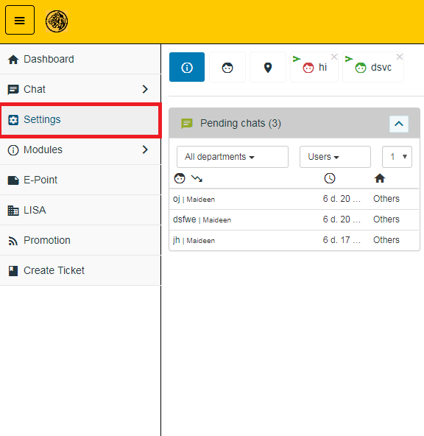

Figure 1: Click Settings at left panel

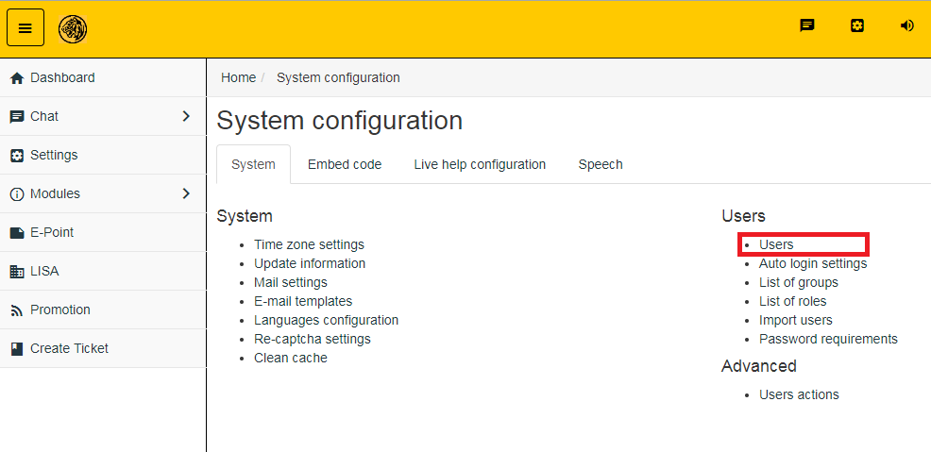

Figure 2: Click Users under Users list

### New User

Click the New User button at the bottom of users table.

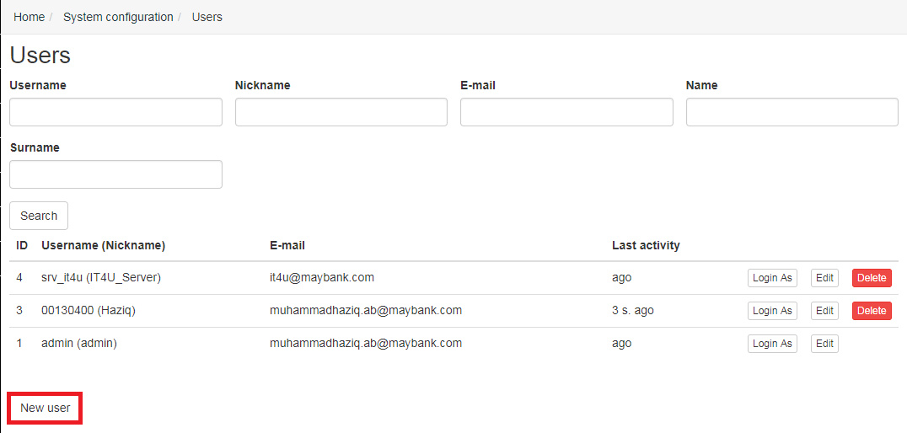

Figure 3: Click New User Button

### Fill User Information

Fill the form related to Agent information.

#### Agent Information

Fill in the Agent information like in list below:

1. **Username** : PF Number
2. **Email** : Agent Email
3. **Chat Nickname** : Nickname
4. **Name** : First Name
5. **Surname** : Last Name
6. **Job Title** : “Leave blank”

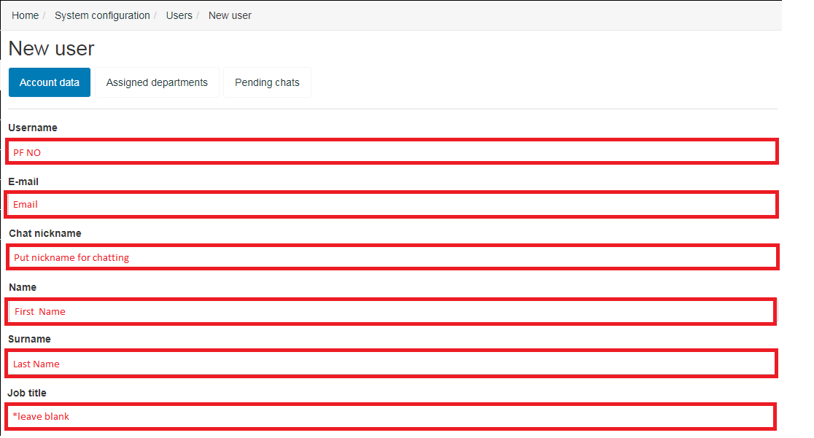

Figure 4: User Information Form

#### Agent Setting

* + - 1. Set timezone to Asia/Kuala Lumpur



* + - 1. Set the Agent’s role in user group field

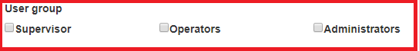

* + - 1. Leave blank for this section

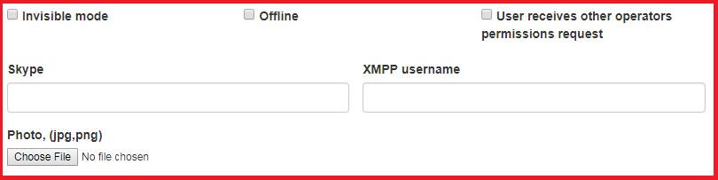

D:\Livechat\pic\UC4e.PNG

## Assign Departments

Department need to be assign for agent to receive chats as user will choose the subject in chat widget that relate to department to assign the agent.

### All Department

This option will give the access to user for all chat from all department and do not select this option for agent that will cause the agent to receive all chats from all departments.

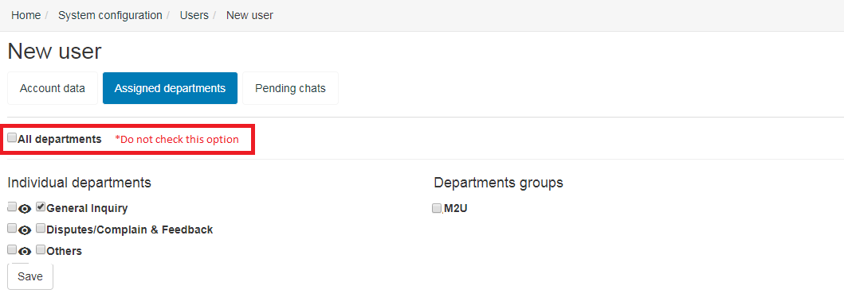

### By Individual Department

This option allow user to select individual department by choice. There are 2 checkbox to select that can only be select one for each department. First checkbox is only visible the chat from respective department and second checkbox is for access the chat for that department.

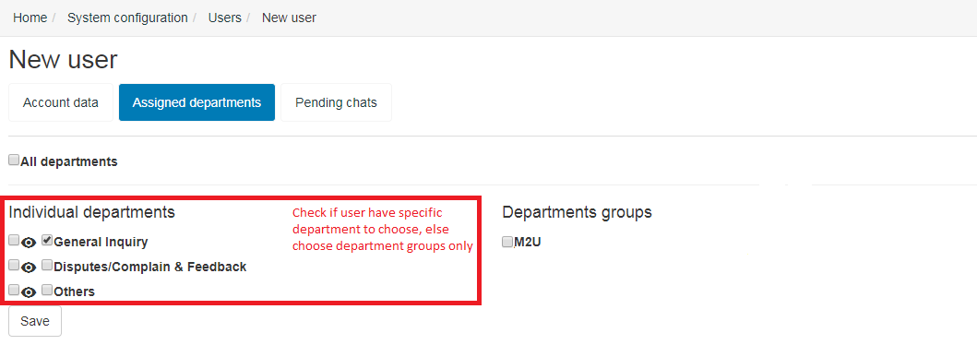

### By Department Groups

This option is batch department assignment and the department group has been setup by Admin. The list of department in department group will be given by Admin.

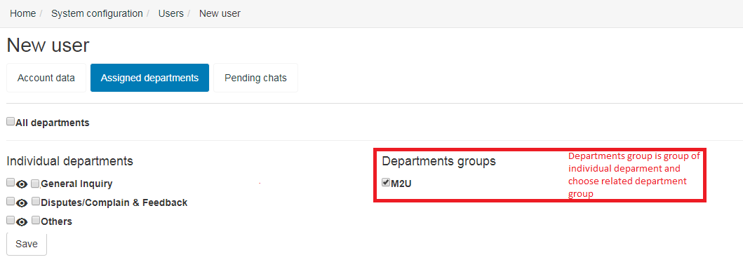

## Pending Chats

### Automatic Accept Chat

Select this option if Agent want automatically accept pending chats that already assign to the Agent.

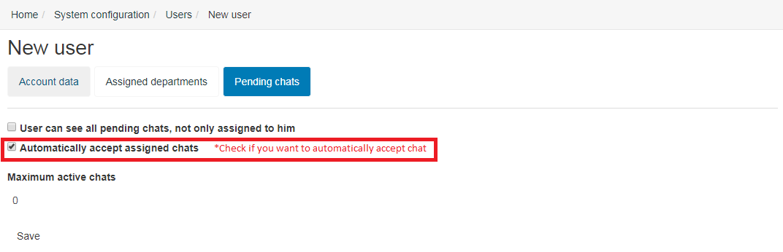

### Maximum Active Chats

Set a number of maximum active chats for Agent to handle concurrently. If the number is set to 0, the function will disable and Agent will have unlimited active chats concurrently.

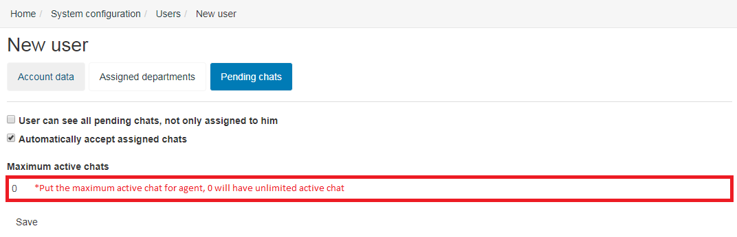

### See All Chats

This option will give the Agent to see all department regardless the assigned department. Avoid to select this option to focus the Agent to assigned department chats.

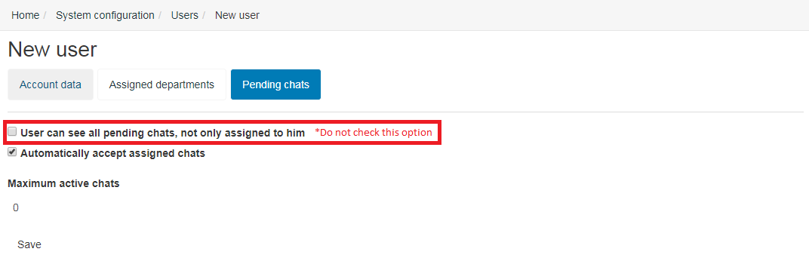

## Agent Account List

This is the list of users in Maybank Livechat. There are functionality to search, edit and delete Agent.

### Search Agents

Agent can be search by Username, Nickname, E-mail, Name and Surname.

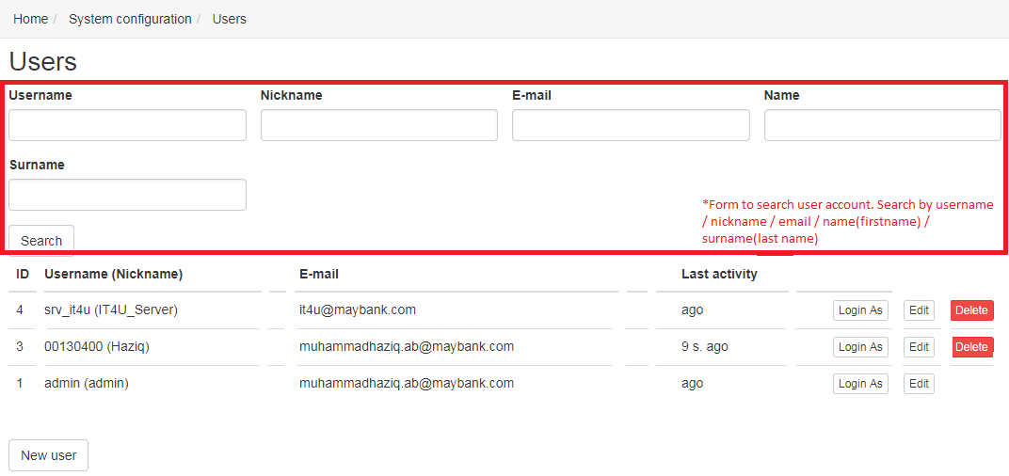

### Delete Agents

There is a delete button in each row of users respectively.

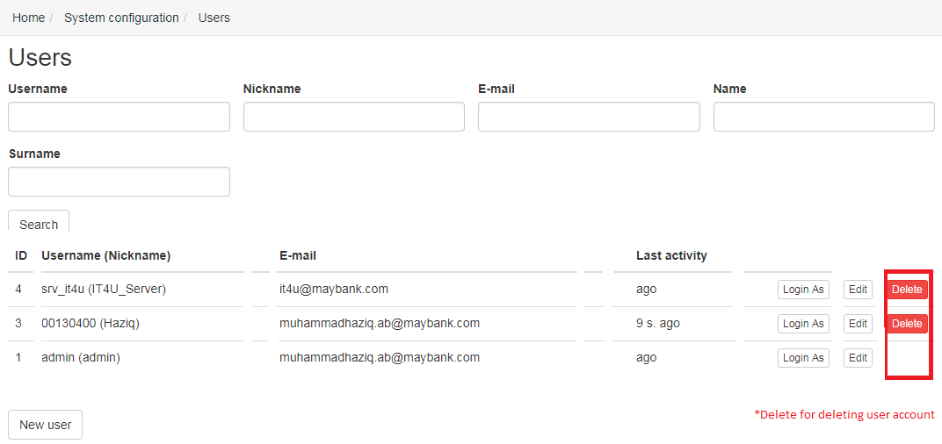

### Edit Agents

There is an edit button in each row of users respectively. The view is same with create new user and there are 2 additional tab that are Permission and Speech tab.

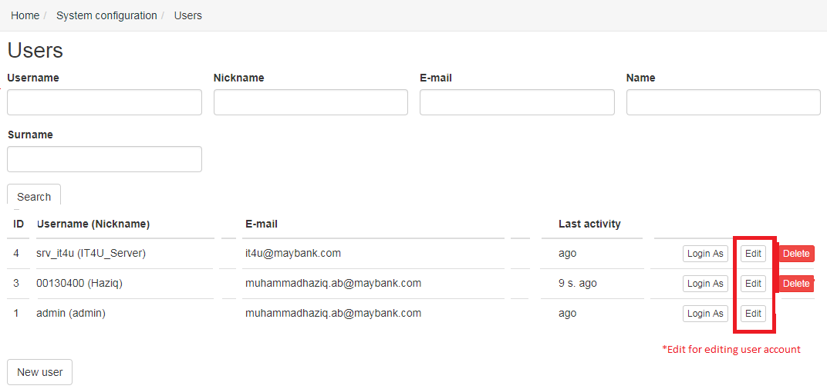

#### Permission Tab

This tab shows the permission given for related Agent. It only for display and not to set permission. Set permission is under Admin role.

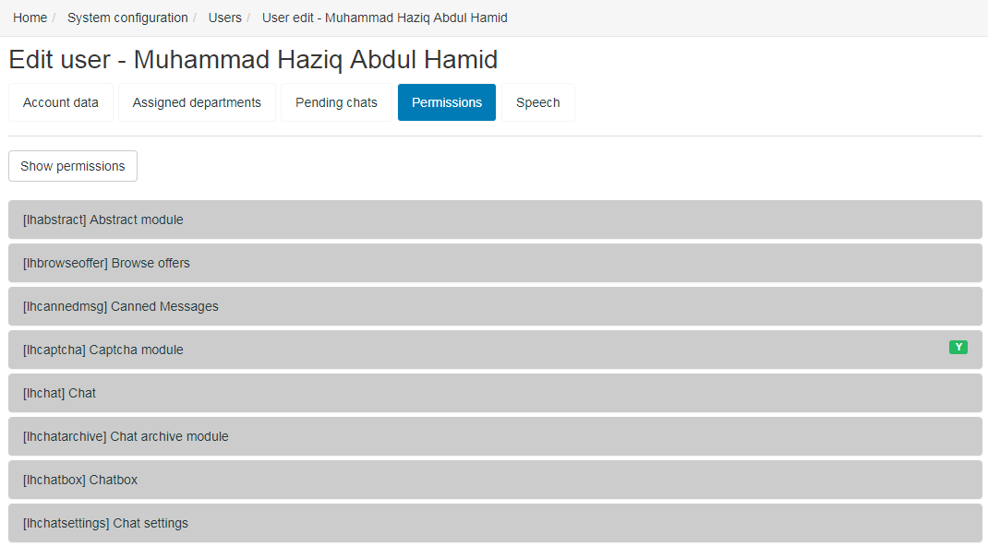

#### Speech Tab

This tab is for set the language for the Agent. Please leave it if not required.

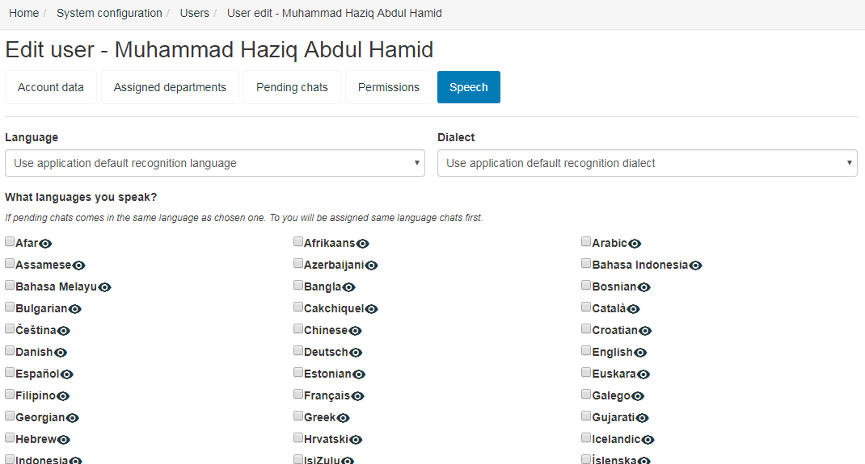

## Agent Account

Agent does not have access to edit account like Supervisor or Admin. Agent need to go to **Username** (Right Top) > **Account**.

D:\Livechat\pic\UR11.PNG

### Edit Personal Information

Agent can edit personal information here and do not change the password.

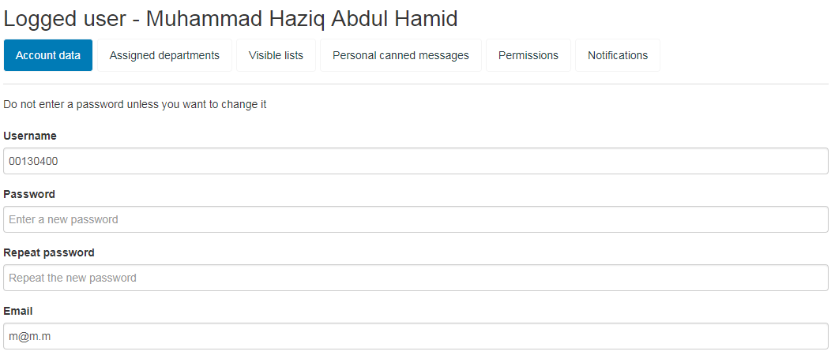

# Chat Configuration

## Auto Responder

This function will display message automatically to user and can be setting by default for all agent. Go to **Settings** > **Live Help Configuration** > **Auto Responder**.

### Welcome Message

Welcome message will display after user start chat and waiting chat to accept by agent as the first message in chat sequence. Create new Auto Responder by department and fill in the required field below:-

1. **Name**: Set name for Auto Responder
2. **Department**: Select related Department
3. **Wait Message**: Fill the Welcome Message
4. Other field leave it blank/as default.

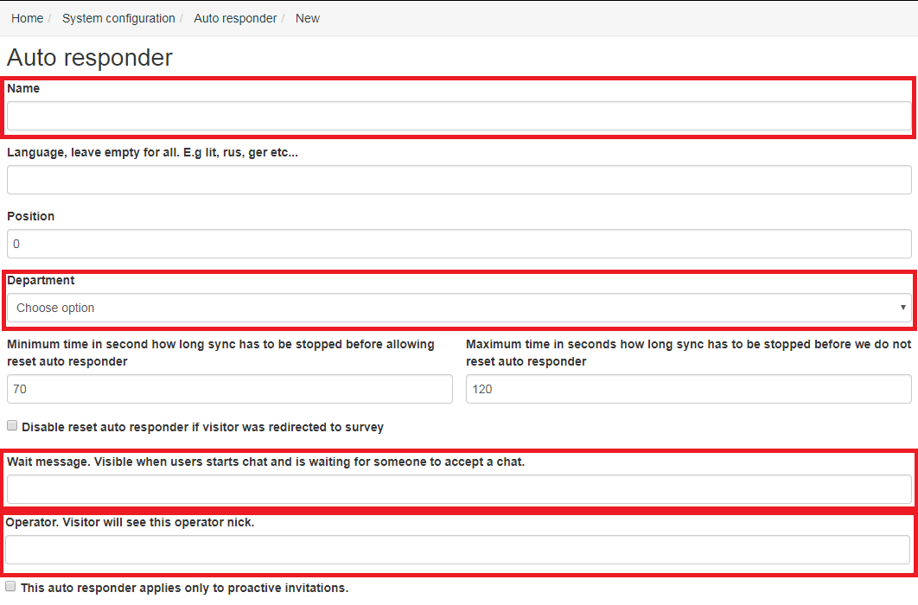

### Pending Chat Message

Pending chat message will display if chat not assigned to any agents. Go to Pending Chat Message tab.

1. Check this option to stop auto responder as chat is assigned to Agent.



1. Leave this option as it not required.

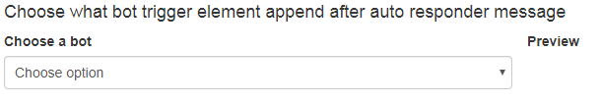

1. Choose a trigger for pending chat auto responder. Wait Timeout field is the time for auto responder to trigger in seconds and next field is the message to display. There are multiple wait timeout field that will trigger one by one according its priority. Wait Timeout [1] will display first and Wait Timeout [2] is next message to display and so on.

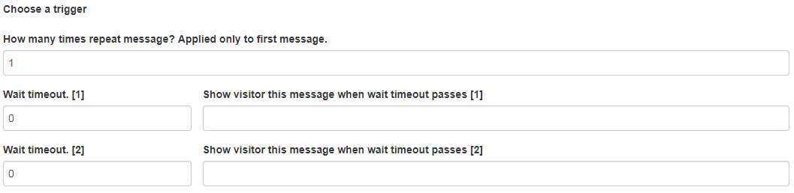

### Agent Not Response Message

This message will display if agent not response in >n minutes. Go to Not Replying Messaging.

1. Leave this option as it not required.



1. Choose a trigger for agent not response message. Set the timeout when agent not responding in seconds and next field is message to be display. Timeout [1] will display first and follow by Timeout [2] and so on.

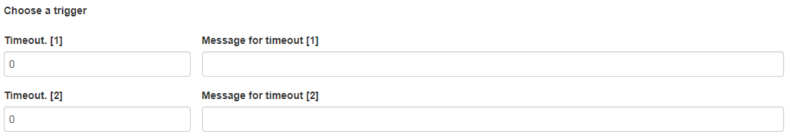

### Hold Chat Message

Hold chat message will display if agent click hold button. Go to Hold Message tab.

1. Set the default message if Hold button is click.



1. Set the timeout message if message is still in hold and message will come out according it time in seconds and its respective messages.



## File Attachment

File upload will be done by Supervisor and Agent will only see the list of file.

### Upload File

This feature is available only for Supervisor and Admin only. Go to **Settings** > **Live Help Configuration** > **List of files**.

1. Click Upload a file button.

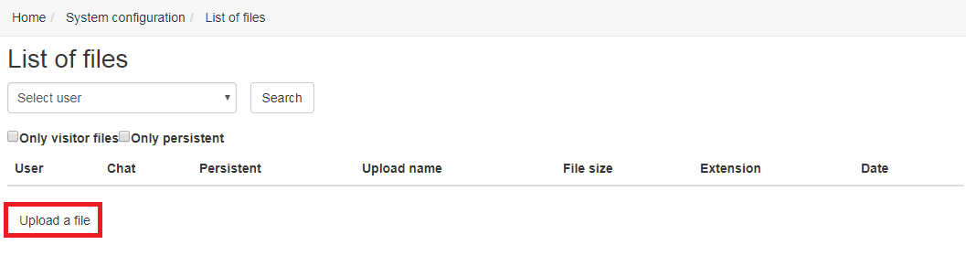

1. Choose a file from local directory.

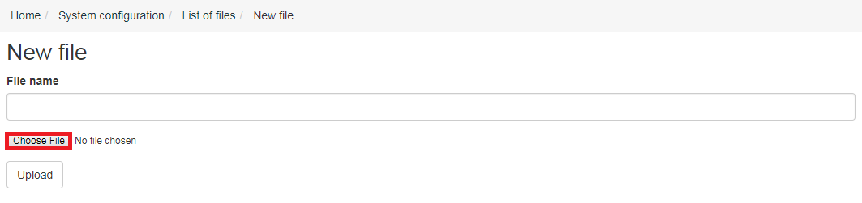

1. Click Upload button.

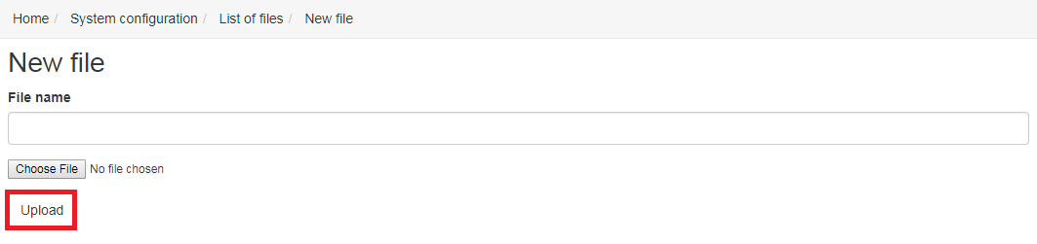

### Attach File in Chat

Attach file into chat can be done by click attach icon in left panel. The view for supervisor and agent will be different as show below.

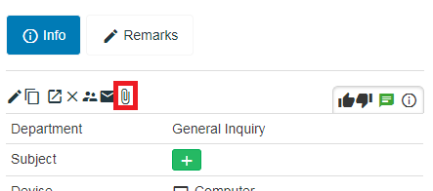

1. View as a Supervisor. There is upload button to upload file

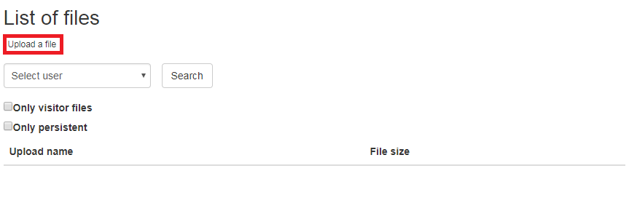

1. View as an Agent. There only list of file to choose to be attached in chat.

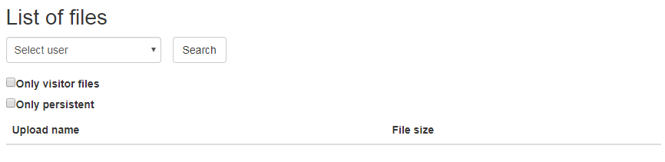

## Block User

Blocking a user can be done by Country or by IP Address.

### By Country

This feature is to block Maybank Livechat icon from display by detect the user GEO location. For this module to work, geo detection need to be configured. Go to **Settings** > **Live Help Configuration** > **GEO Adjustment**.

1. Select option GEO adjustments active



1. Select this option to enable this module and state the code of country that will display widget normally.

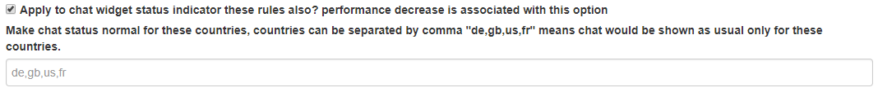

1. Then state the country code other than above to effect the below effect in widget display. Option all for all country and custom for selected country.



1. Set country listed above whether to offline or hide the widget and not state country in any fields above to offline, hidden or normal status.

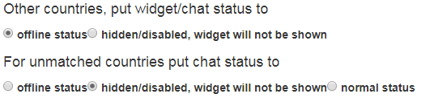

### By IP Address

This feature is to block user from specific IP Address. Go to **Settings** > **Live Help Configuration** > **Chat Configuration** > **Online Tracking.** Put the IP in the **RED** field. The possible value to put in are Wildcard format (1.2.3.*), CIDR format (1.2.3/24 OR 1.2.3.4/255.255.255.0) and Start-End IP format (1.2.3.0-1.2.3.255).

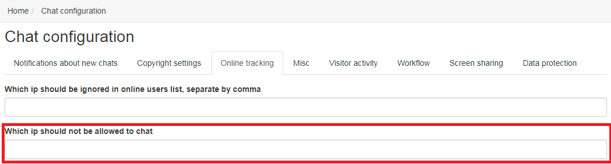

## Chat Assignment

Chat assignment to operator is based on department selected by user. The assignment of chat depends on department setting. The chat will assign in round robin. Go to **Settings** > **Live Help Configuration** > **Department** > **Department** > **Edit Department** (select a department) > **Auto Assignment.**

### Auto Assign Chat

This feature is automatically assign chat to user. Click Active option to activate.

D:\Livechat\pic\UC19.PNG

### Active Chat per User

This feature is to determine the active chats per Agent. Set to a number for Agent to handle chats concurrently and 0 will have unlimited number of chats concurrently. If the agent reach maximum chat per user, the chat assignment will skip the agent and assign to other free agent.



### Active Chat per Department

This feature is to determine the active chats per Department. If all agent in department reach maximum chat per user, the department will be offline.



### Auto Assign Chat to Other Operator

This feature is automatically assign chat to other Agent if the assigned

Agent is not responding in required times. Set this field the value of required time in seconds for Agent to respond before it assigned to other Agent.



### Delay between Chat Assignment

This feature is delay the new chat assignment to agent. Set the value in seconds before Agent is assigned to new chat.



## Message Character Limit

This feature will limit the character per message. Go to **Settings** > **Live Help Configuration** > **Chat Configuration** > **Misc**.

### Maximum Message length in Character

Scroll down under Chat Related title. Set the value for character per message.



## Canned Message

Canned Message is a prepared message use for standard question. There are Department Canned Message and Personal Canned Message.

### Department

Department Canned Message is a default canned message that available to all Agent in related department. Go to **Settings** > **Live Help Configuration** > **Canned Message**. Only Supervisor will set department canned message.

1. Create new canned message

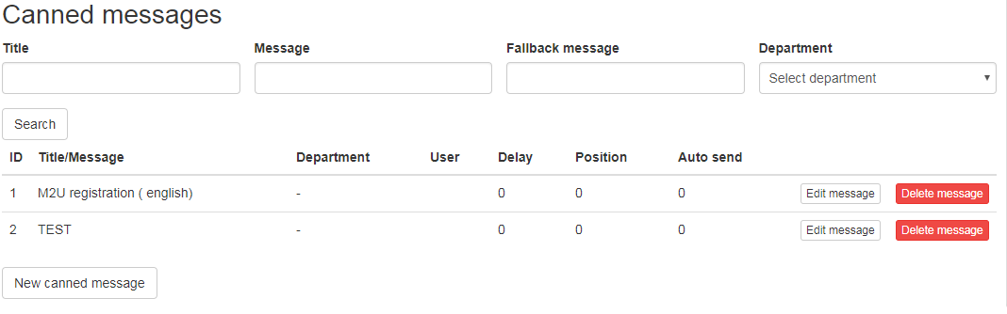

1. Fill in the Title for naming, Explain for description and Tag’s for tagging.

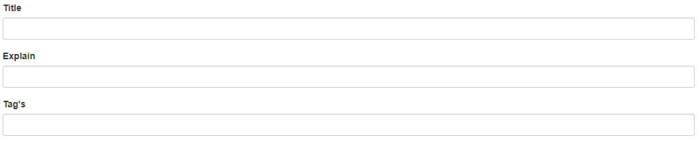

1. Select this option to display personal welcome message when Agent accept the chat. Do not select if this is not welcome message



1. Fill the message and fallback message for canned message.

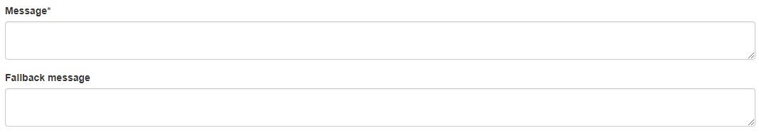

### Personal (Agent)

Personal Canned Message is a personal canned message that only available to Agent who make it. Go to **Name** (Username [Right Top]) > **Account** > **Personal Canned Message.**

1. Fill in the Title for naming, Explain for description and Tag’s for tagging.



1. Select this option to display personal welcome message when Agent accept the chat. Do not select if this is not welcome message



1. Fill the message and fallback message for canned message.



## Survey

This feature is to prepare the survey for user to rate the service of Maybank Livechat. Survey can be automatically display to user at the end of chat or manually directing user to survey.

### Create Survey

Create the survey template. Go to **Settings** > **Live Help Configuration** > **Survey**.

1. Click New Survey button.

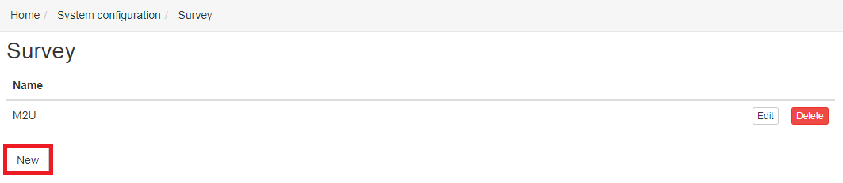

1. Fill in the name of survey in Name field and Feedback Text for message after user finish the survey.

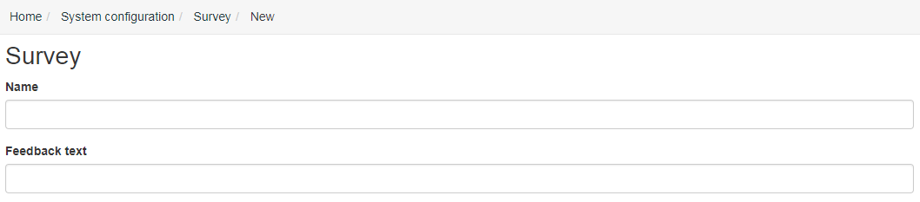

1. Select one of survey type:-
   * + - 1. Star :-

Select Required checkbox if this survey is required.

Fill Title for evaluation fields for survey message.

Set the value of maximum stars for feedback.

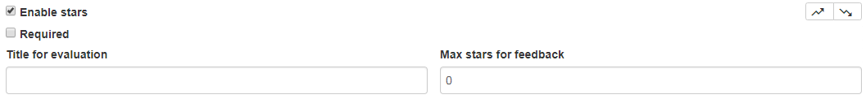

* + - * 1. Question with answer:-

Select Required checkbox if this survey is required.

Fill in the question for survey.

Enter the possible answer for related question.

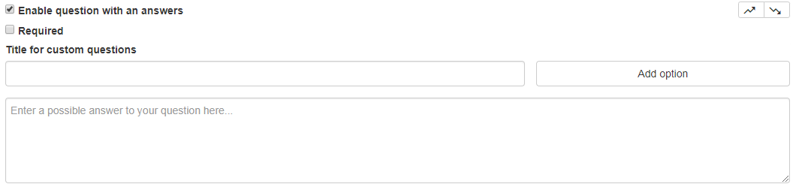

* + - * 1. Question:-

Select Required checkbox if this survey is required.

Fill the question for survey.

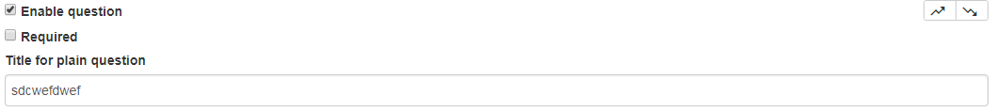

### Direct User to Survey

This is manually survey that Agent will redirect user to survey during the chat session.

1. Click the Survey button.

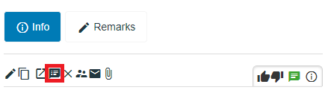

1. Select survey to be directed to user and click request user button.

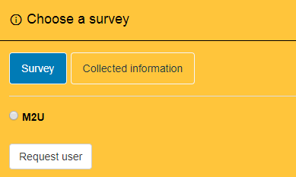

1. The green message will appear to indicate user have been redirect to survey.

